Chapter22:

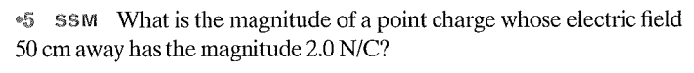

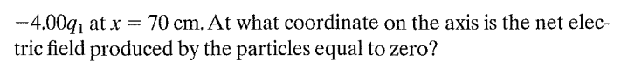

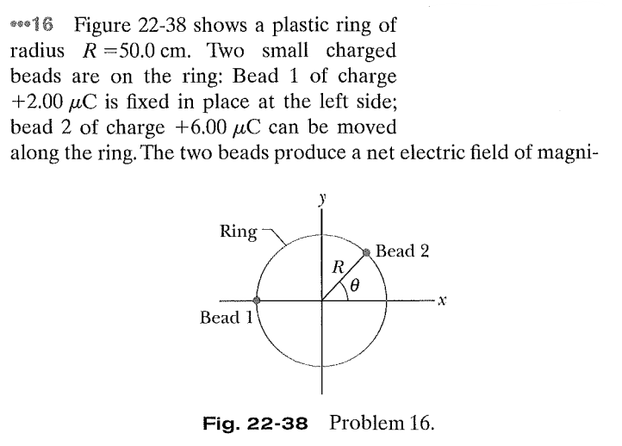

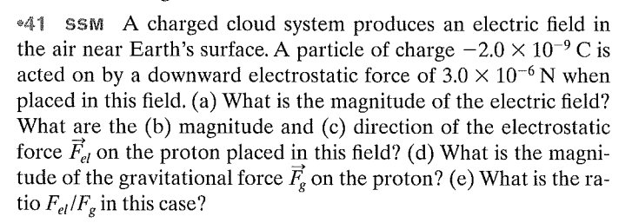

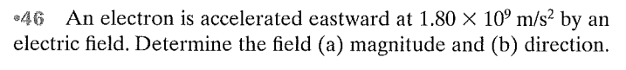

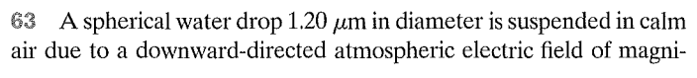

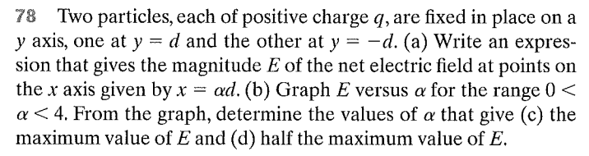

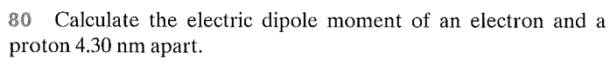

Questions:

